

Subject: Object oriented programming

Assignment #: assignment:4

Group members

Fatima kashif (sp24-bse-144)

Zara baig (sp24-bse-128)

Ayesha Kamran(sp24-bse-021)

Section:A

Due date:20-12-2024

Recipe book application

=>Login stage:

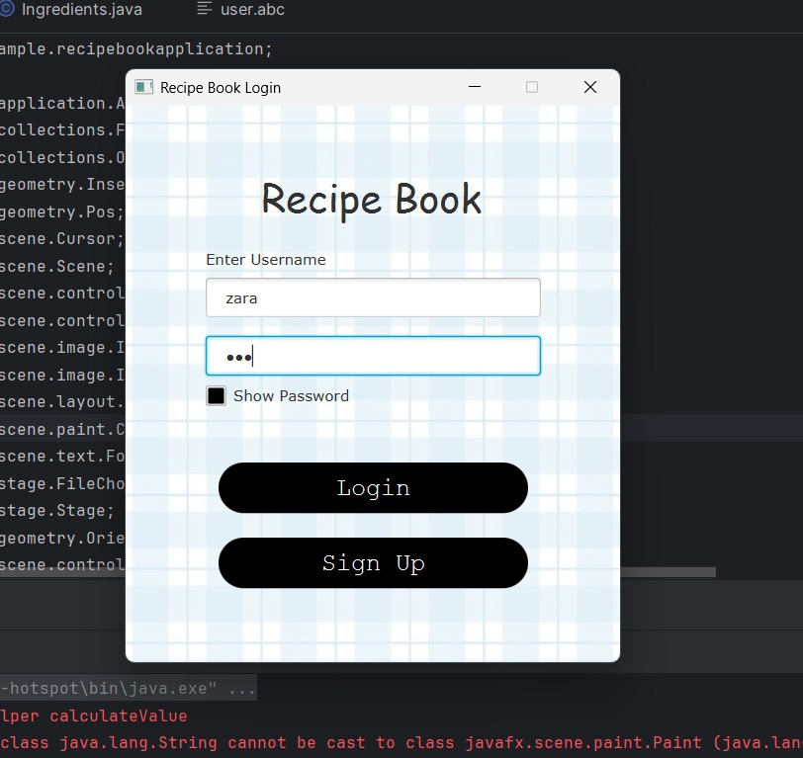

This is login stage .Here users enter their name and password to login if they have already sign up. If their name and password match with the record of user.txt file.They can login easily. .

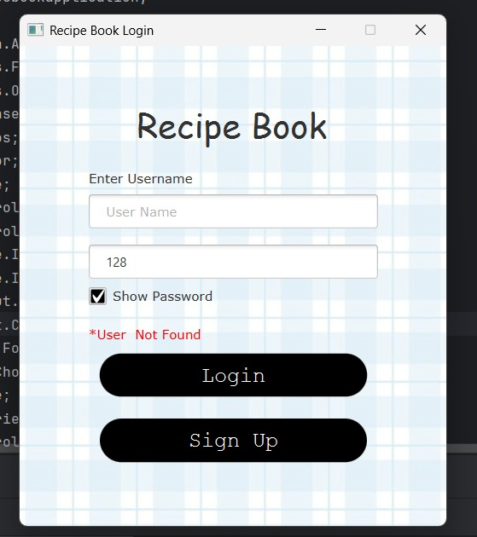

Here are two functionality first is show password and second is user not found.If user info. Don’t match with data in file user not found alert pop up.

=>Sign-stage :

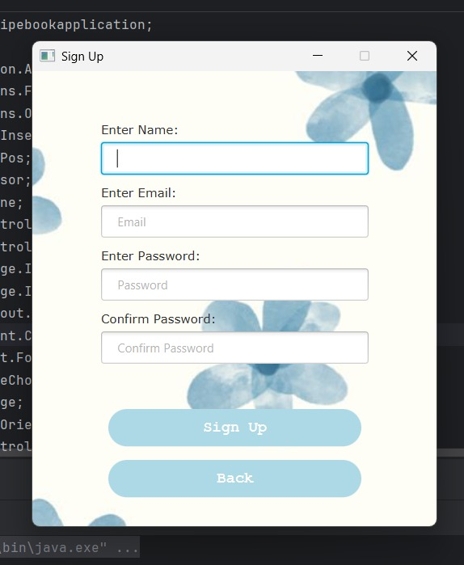

This is sign up stage.This is for new users.Firstly they have to create a account by sign up.

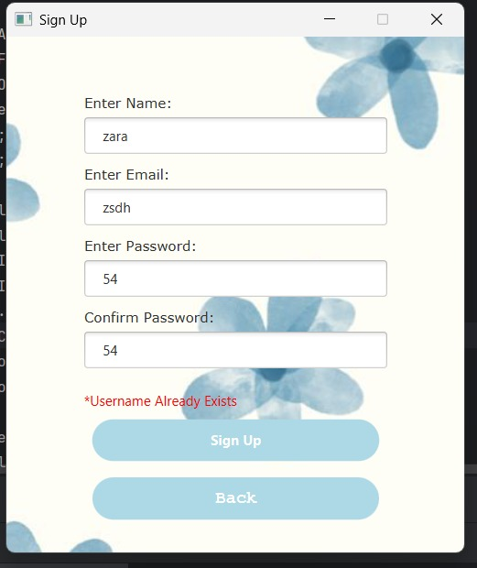

If user enter such name which is already registered .Then alert username already exists pop up.So,it keep a check on so two user with same data don’t confuse the system.

=>Menu stage:

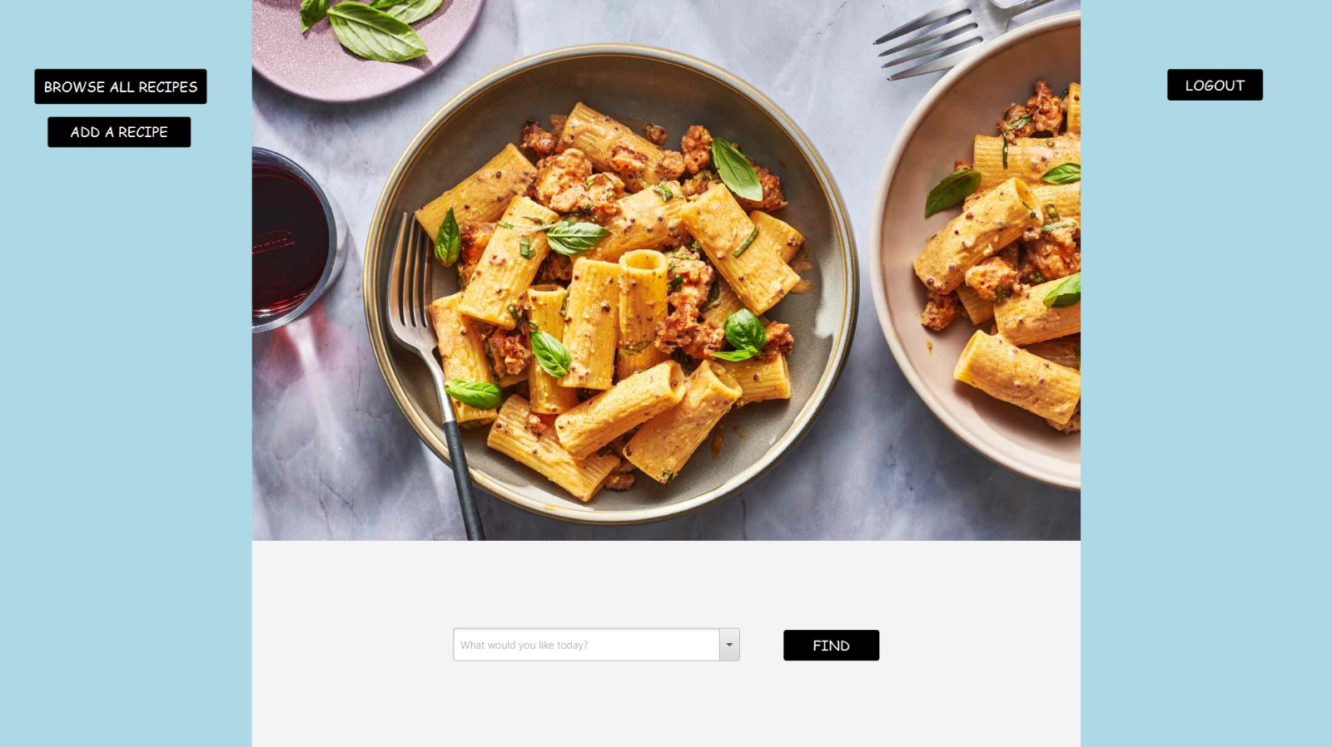

When user successfully login or sign up .It takes user to menu stage .Menu stage provides different functionalities like add a recipe ,browse recipes and find recipe.It used border pane layout.On left side it also provides log out functionality.

=>Add stage:

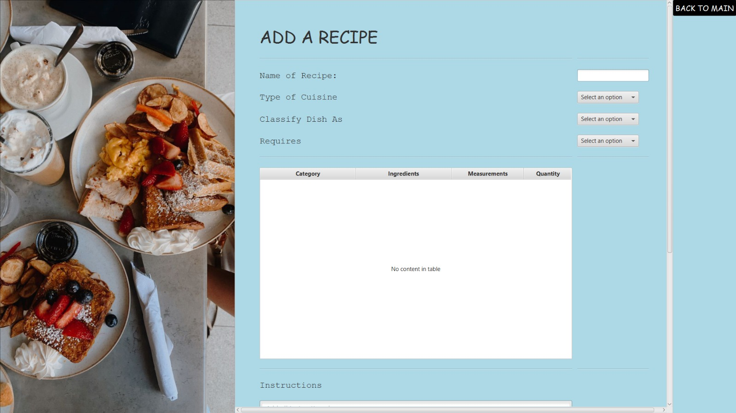

To add a recipe firstly you have to name it.Then you can select a cuisine like Asian,italic etc from dropdown.Also like ctagory and requirements from combo box.At the table you select ingredients and measurements.

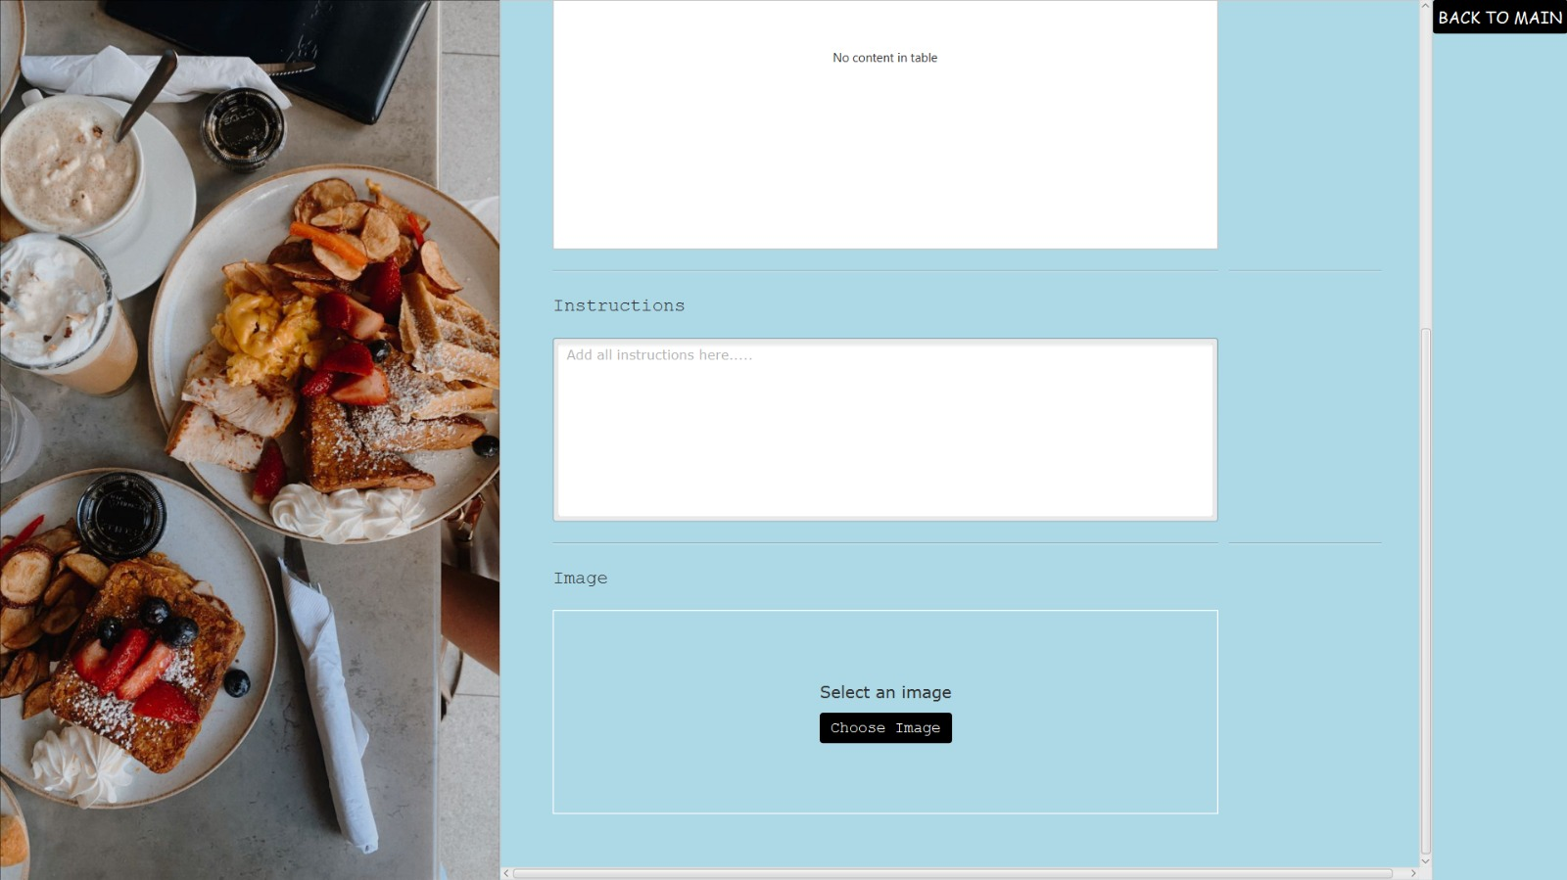

You can also add instructions for your recipe in textarea.You xan also upload a picture of your dish.Lastly it also provide a scroll bar option to scroll doen smoothly.

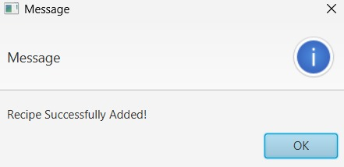

Browse recipe:

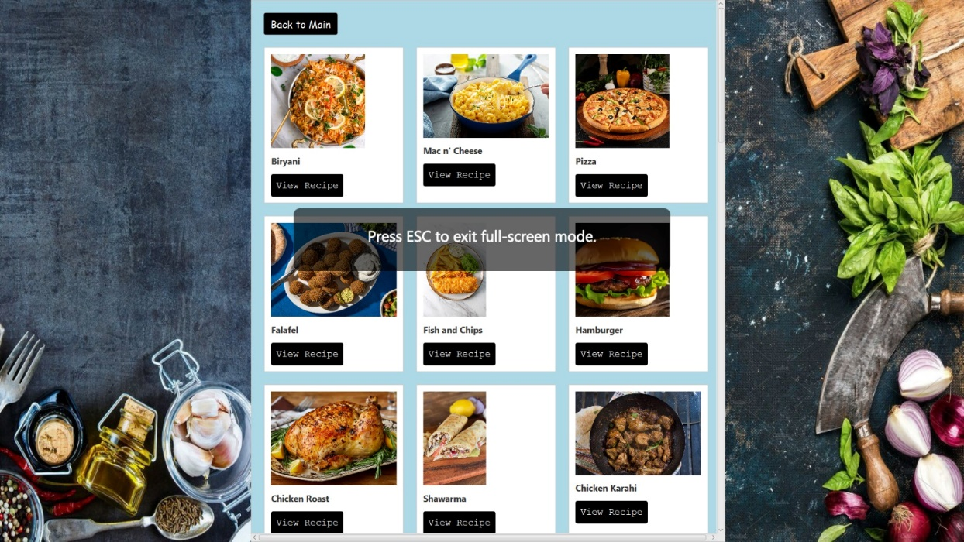

Browse single recipe view:

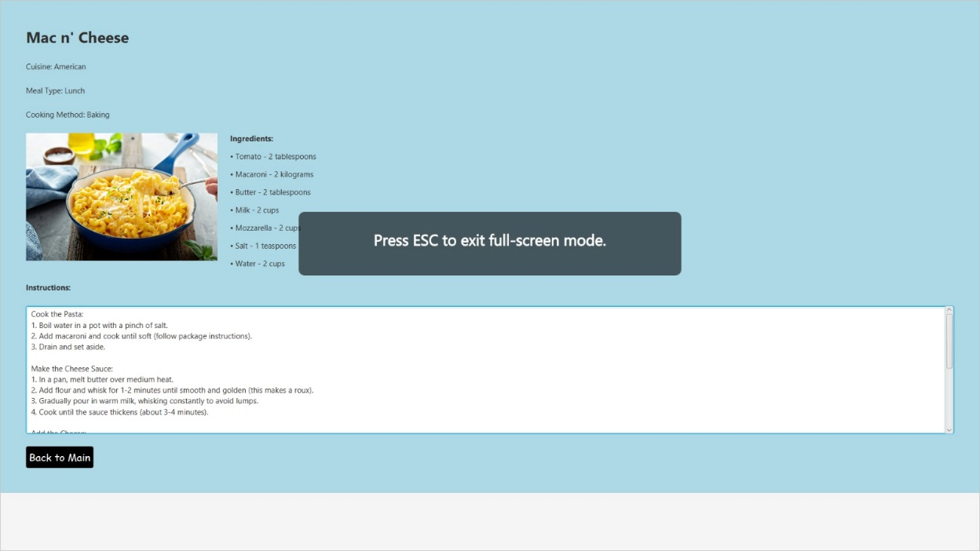

Find recipe:

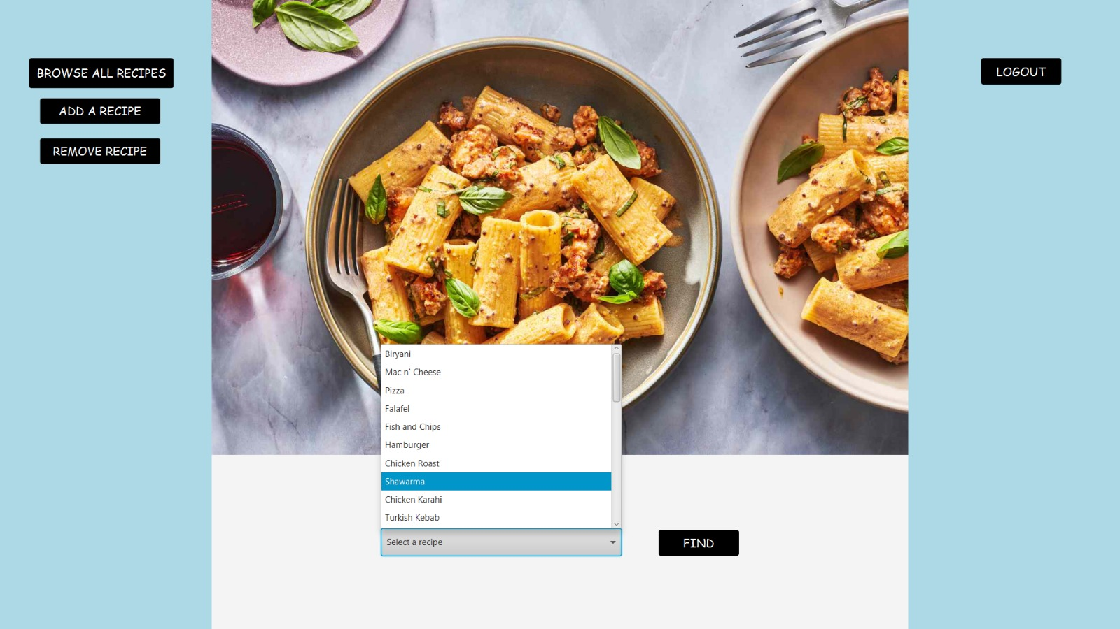

Find recipe view:

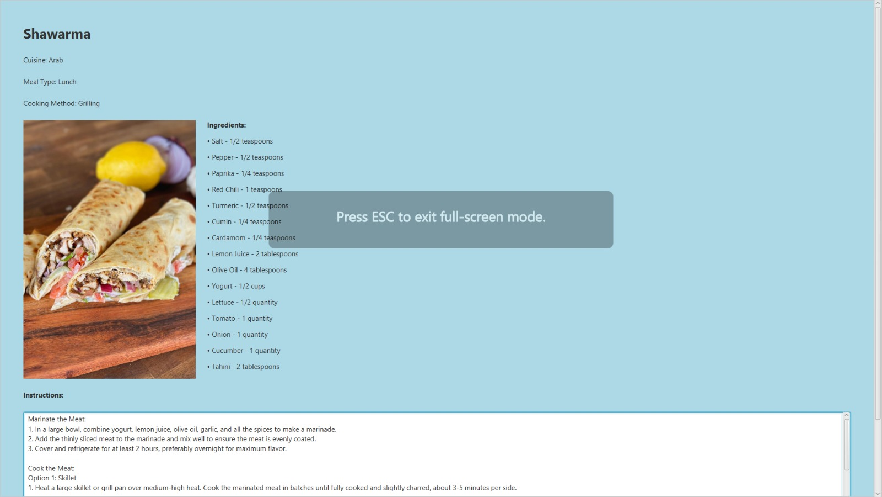

Remove recipe:

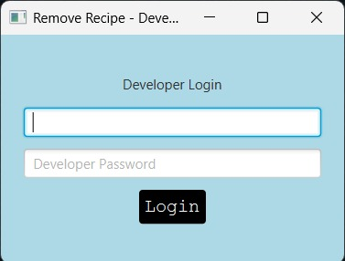

Valid remove:

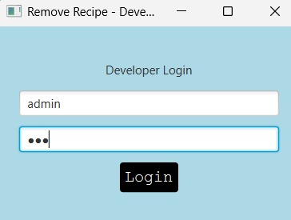



Invalid remove:

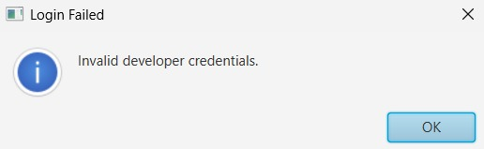

The

End